**Devops**

Docker is a platform that provides virtual containers on which an application can be deployed independent of the underlying OS of the server. Further the container can be created from a replica called docker image which contains all the dependencies and can run on any OS that has docker engine, with similar results.

**VIRTUALIZATION:**

Virtualization is the process of sharing hardware resources across several virtually isolated and mutually independent systems. It is achieved by using a hypervisor which acts as a bridge between the Operating System of each of the virtual machines and the underlying hardware.

Applications in virtual environments run on a host operating system on top of the hypervisor.

**BASIC DOCKER COMMANDS**

#Display docker images available in our machine

$ docker images

#Download docker image.

$ docker pull <image-name / image-id>

#Run docker image.

$ docker run <image-name / image-id>

#Delete docker image.

$ docker rmi <image-name / image-id>

#Display all running docker containers.

$ docker ps

#Display all running and stopped containers.

$ docker ps -a

#Delete docker container.

$ docker rm <container-id>

#Delete docker image forcefully.

$ docker rmi -f <image-id>

#Stop Docker container.

$ docker stop <container-id>

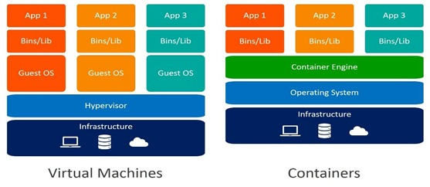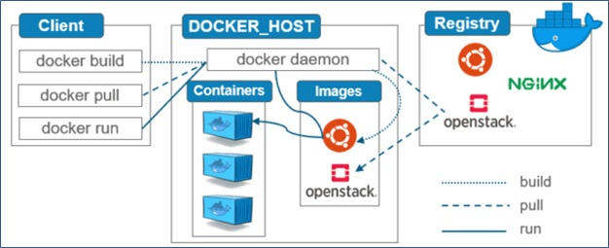

**#DOCKER COMMANDS FOR UBUNTU**

$ sudo apt update -y

$ sudo apt install docker -y

$ sudo service docker start (or) sudo systemctl start docker

$ sudo service docker enable (or) sudo systemctl enable docker